The Journey to the Tarta de Santiago
All pages will use the same layout, font, etc.
Index:
- Title: Welcome to the Sweet Journey
- Paragraph: You arrive in Santiago de Compostela, where the scent of almonds and sugar drifts through the narrow stone streets. Legends say that the secret to the perfect Tarta de Santiago lies scattered across Galicia, hidden ingredients waiting to be rediscovered. Your mission begins in Teddy´s kitchen, where the first clue to the recipe awaits. Click to begin your journey.
- Image: 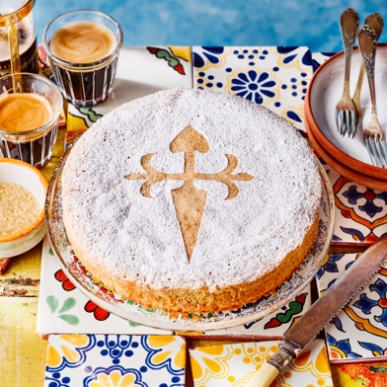
Page2:
- Title: Level 1 - Eggs
- Paragraph: You arrive at Teddy´s kitchen. Among the wooden utensils lies the five eggs required that will begin your journey. Look carefully, they’re hidden in plain sight! You must click the square root of 4 egg to continue (second egg).
- Image: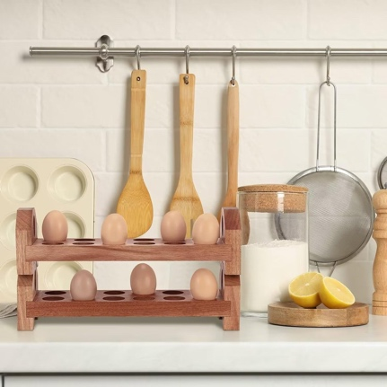
Page3:
- Title: Level 2 - Sugar
- Paragraph: The scent of sweetness fills the air. Somewhere in this busy market lies the sugar you’ll need to sweeten your creation. Click… ¡Good Luck!
- Image: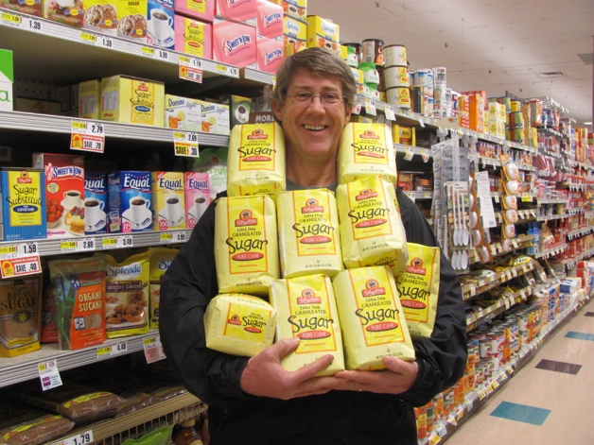
Page4:
- Title: Level 3 – Ground Almonds
- Paragraph: Which one should we use… this is the soul of the Tarta de Santiago, don’t mess it up.
- Image: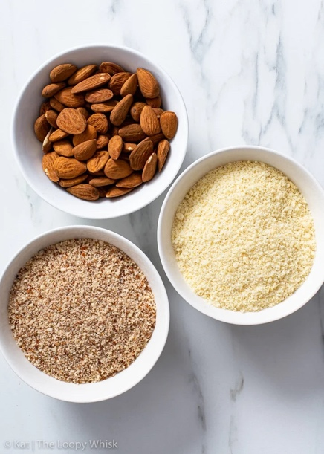
Page5:
- Title: Level 4 – Lemon Zest
- Paragraph: A touch of brightness for your cake. Search the perfect lemon, its zest will bring the flavor to life.
- Image: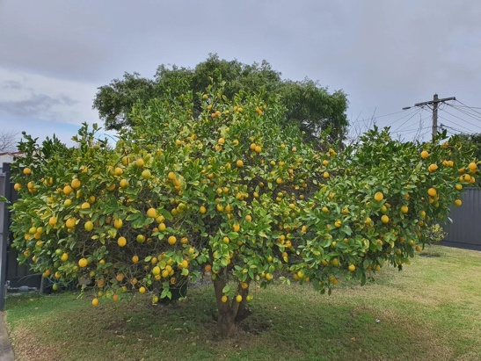
Page6:
- Title: Level 5 - Cinnamon
- Paragraph: “Now for the aroma of tradition, a teaspoon of cinnamon. Find it among the jars of spices and herbs in trader joe´s.”
- Image: 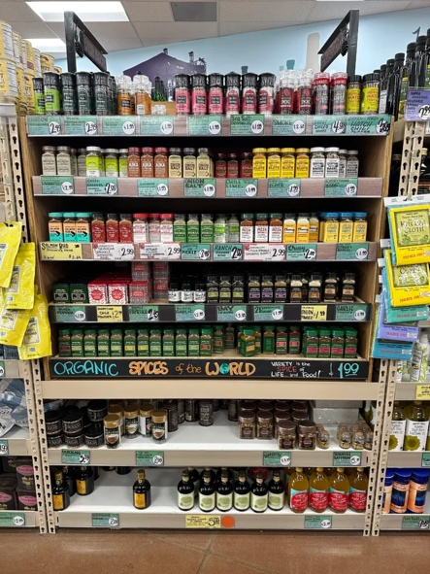
Page7:
- Title: Level 6 – Powdered Sugar
- Paragraph: “The final touch of magic: powdered sugar for the Cross of Santiago. Which bake contains powdered sugar?
- Image: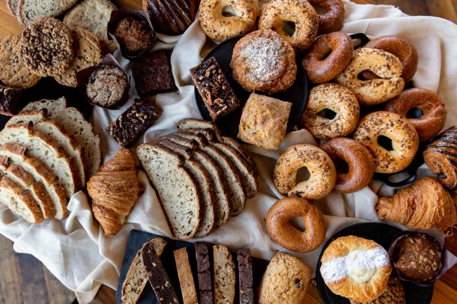
Page8:
- Title: The Cake is Ready!
- Paragraph: Congratulations! You did it! You’ve gathered all the ingredients: 5 eggs, 250 g sugar, 250 g ground almonds, Lemon zest, 1 tsp cinnamon, Powdered sugar to decorate. Mix everything, bake at 180 °C for 35–40 minutes, and decorate with the Cross of Santiago. A cake made of tradition, patience, and discovery. Buen Provecho!
- Image: 